Bandit Level 10
DG Interns Hub | Week 1 | OverTheWire Bandit Writeup

Objective
Extract readable text from binary-like data.

Activity summary
Suggested learning command / approach: strings data.txt | grep "=". Use only on the authorized OverTheWire training environment.

Key learning
Extracting printable strings.

Evidence
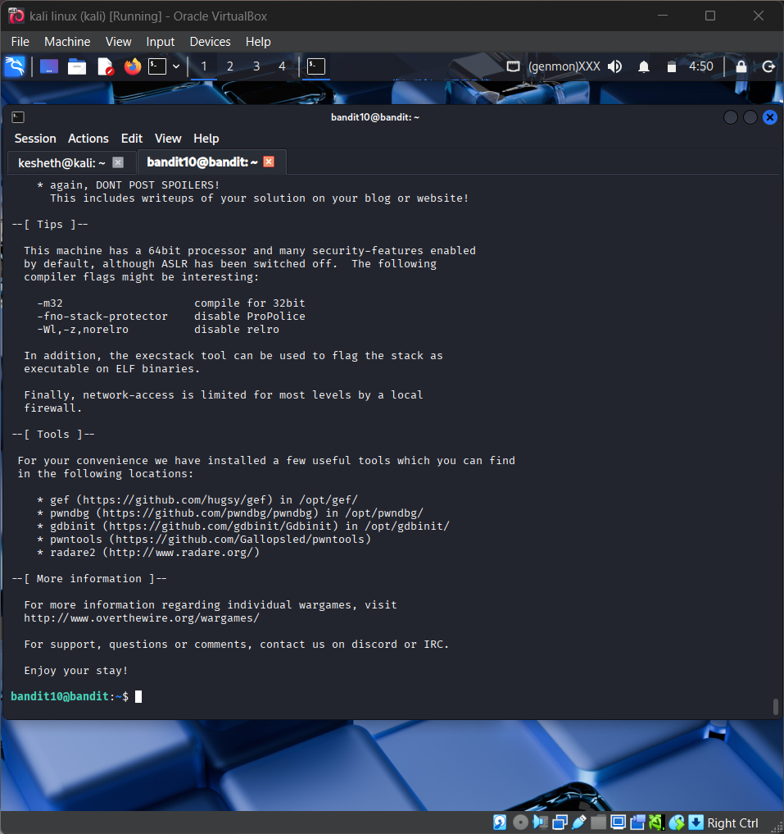
Screenshot: Bandit_Level_10.png
The screenshot is evidence of level activity/login; it may not show every solution step. No passwords are reproduced.

